Amazon

Added and tested on April 27, 2018.

1. 1. To register an account with Amazon, you need to follow the link <https://login.amazon.com/>   
   and click on the button Sign Up.

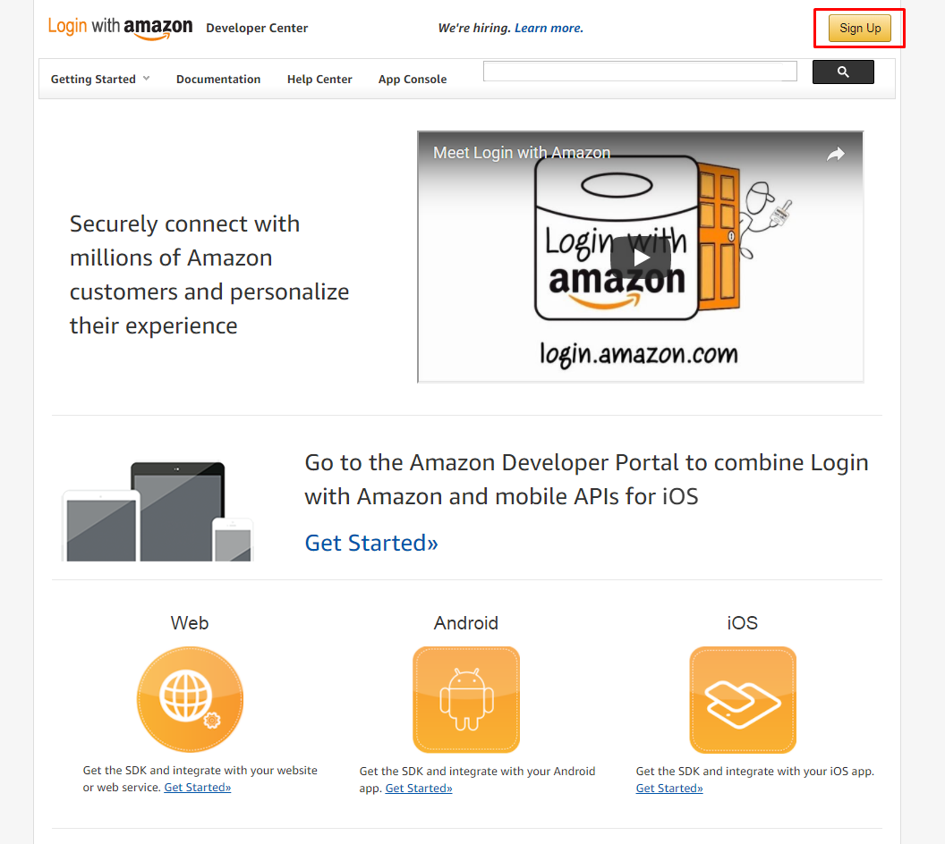

2. In the window that opens, click on the link "Create an Amazon.com account".

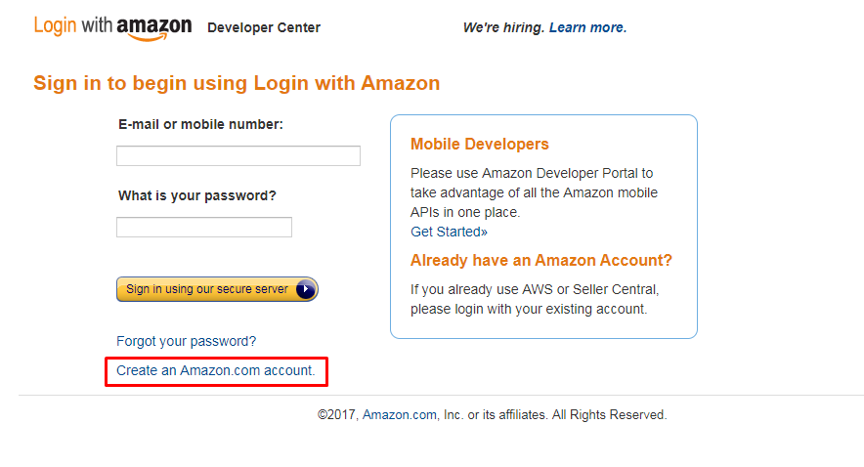

3. In the displayed window it is necessary to fill in the required data and click on the button "Create account".

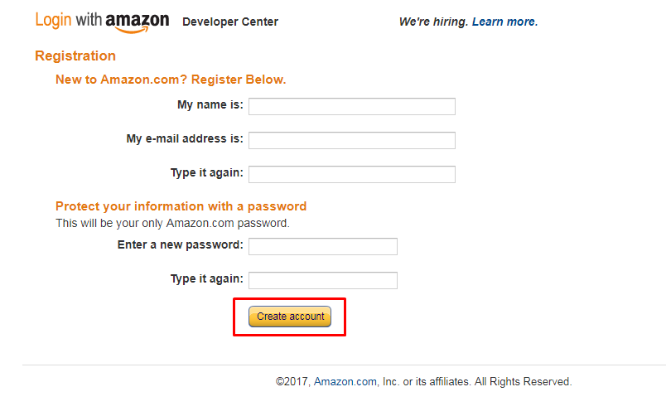

4. Then go through Developer Registration. Fill in all the fields in the form and click on "Get started with Login with Amazon".

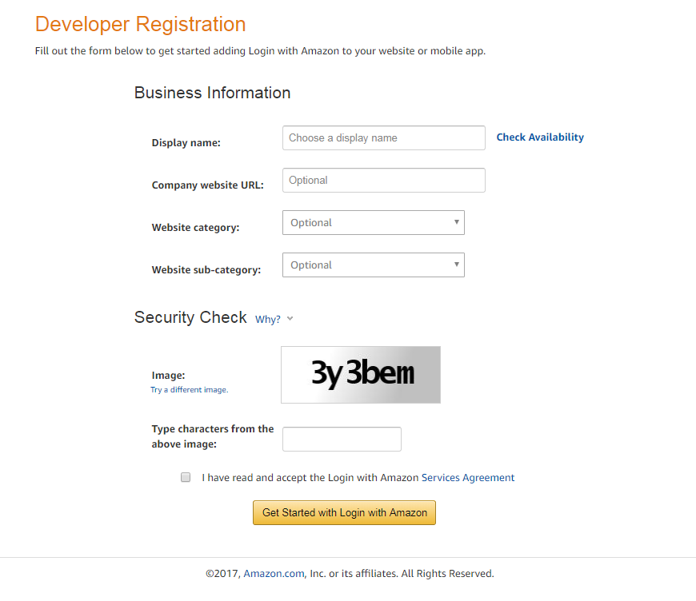

5. Follow the instructions of Amazon.

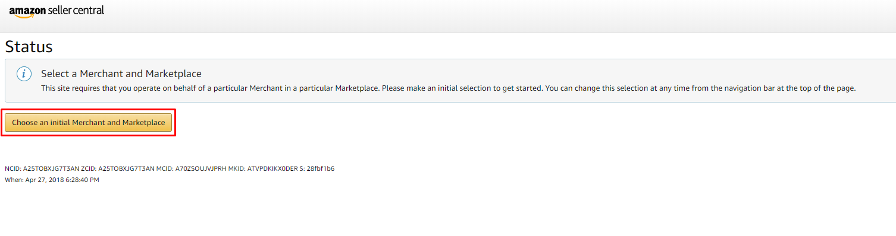

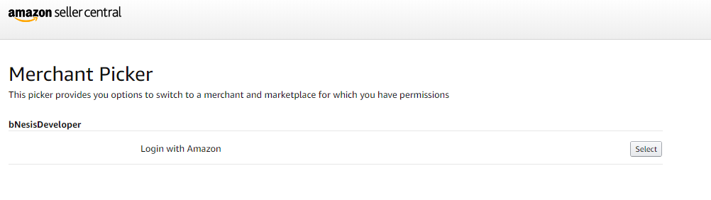

6. To register an application in the opened window click on "Register new application".

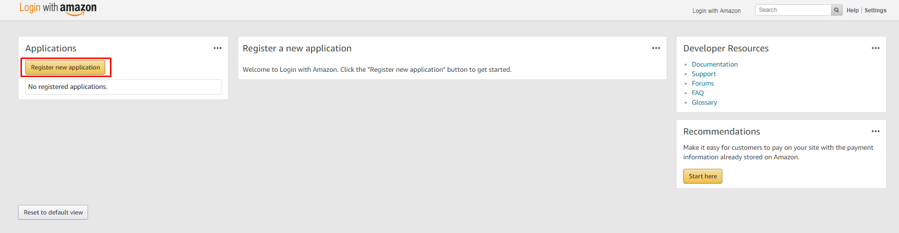

7. In the "Register Your Application" section, fill in all the fields and click on "Save".

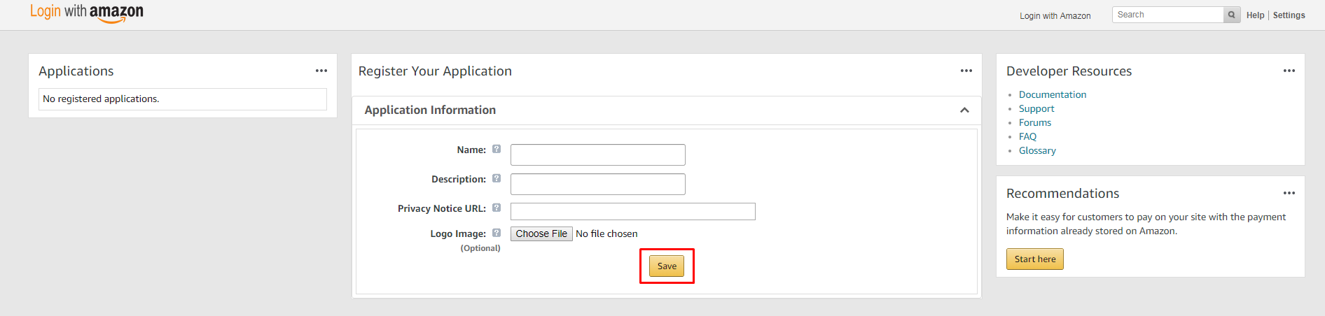

8. Now you can access Client ID and Client Secret.

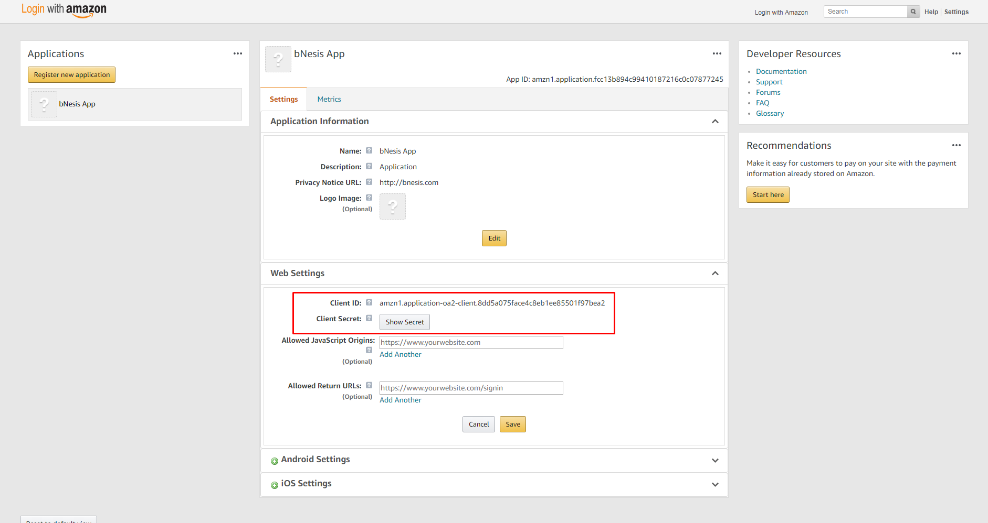

9. In the form of "Web Settings" add the Redirect URL you need.

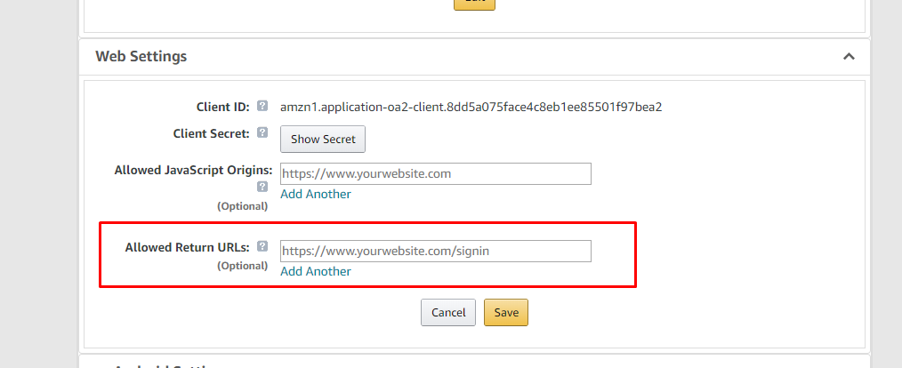

10. Your application will be accessible by reference <https://sellercentral.amazon.com/home>.